|  |  |  |  |  |
| --- | --- | --- | --- | --- |
|  | | Muhammad Usman Amjad | | |
|  | | Frontend Developer | | |
|  |  | | | |
|  | +923437439769 | |  | ABOUT ME |
|  | [usmankashmiri378@gmail.com](mailto:usmankashmiri378@gmail.com) | |  |
|  | Karachi / Sindh / Pakistan. | |  | I am a passionate learning developer, looking for an opportunity in the field of web development. Below in work section you'll find some examples of my work. I am really dedicated to my work. I know editing stuff & Ms-Office automation as well. | |  |
|  | [Usman Kashmiri](https://www.linkedin.com/in/usman-kashmiri-b26543208/) | |  |
|  | [Kashmiri.Dev](https://usman-kashmiri.github.io/Kashmiri.Dev-2.0/) | |  |
|  |  | |  |
|  | | |  |
|  | | |  |  | |  |
| Skills  * MS Office * HTML/CSS/JavaScript * Frameworks (Bootstrap, MDB, Materialize CSS, Tailwind CSS, Animate.CSS) * jQuery/jQuery Plugins (GSAP, WOWJS, AOS) * CMS (WordPress, WIX) * Git Bash/GitHub * Adobe Photoshop * Video Editing (Adobe Premiere Pro/After Effects)  EducationMatriculationSindh Board, Karachi 2015-2017 IntermediateIslamia Sci. College, Karachi 2017-2019 | | |  | My Creative Skills: I've learnt Web designing from Aptech Gulshan Center. And currently working on MS SQL Server, ASP.Net and ReactJS. I've knowledge of HTML/CSS/JavaScript and version controlling using Git. JavaScript libraries, Jquery and AngularJs. Jquery Plugins & JS plugins (such as: GSAP, AOS, WOWJS). I've command over Bootstrap & I can work with latest web frameworks as well (such as: Materialized CSS & Tailwind CSS). I can design responsive websites with custom CSS. I can work with CMS as well (such as: WIX & WordPress). I've written some blogs on WordPress as well. I know MS-Office automation. And I can edit photos & Videos using Adobe Photoshop, Adobe Premiere Pro & I also have basic knowledge of Adobe After Effects. Experience: I am a freshie, I don't have a working experience. I am a student; I've passed my matriculation with A grade in 2017 from Sindh Text Board. I've studied Intermediate from Islamia Sci. College, Karachi. And currently doing software engineering diploma from Aptech Computer Learning Institute. |

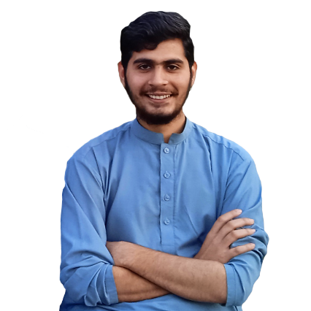

My Portfolio: <https://usman-kashmiri.github.io/Kashmiri.Dev-2.0/>